Doug Payne Clinic
@Hilltop Equestrian Center
Tuesday May 26, 2020
Wednesday May 27, 2020

CLINIC RATES/OPTIONS:
45 minute Private lesson $175.00 ONE DAY OR $300 BOTH DAYS
1.5 Hour Group Lessons 3-4 riders per group $175 Per day Or $325 for BOTH DAYS

Registration Forms on HEC Website or FB page. 2020 Coggins required with Entry. ALL COVID 19 Protocal will be observed to insure everyone’s Safety. If the event of a cancellation due to COVID 19 ALL FEES will be REFUNDED.

Email all questions and entry forms to chipperd17@comcast.net . Payments must be received within 3 days of your entry form to Secure your spots in the clinic.
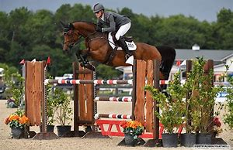

Mail entry & fee to HEC 242 Green St Somersworth NH 03878
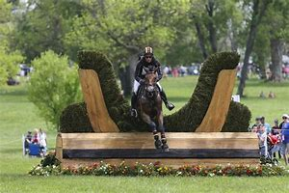
DOUG PAYNE CLINIC
@ HILLTOP EQUESTRIAN CENTER
Entry Form
Date(s) Requested: Tuesday May 26, 2020 Wednesday May 27, 2020

Group lesson Group lesson
Private Private
FLAT FLAT
JUMPING JUMPING
Rider Name: Phone #: .

Address: City& State .

Email: .

Riding Level: .
***Please mail your up- to- date coggins with your entry***
Email: chipperd17@comcast.net Checks to be Made payable to: HEC
Mail Entry and fee to HEC 242 Green St Somersworth NH 03878

I enclosed $__________ for the aforementioned entry. I understand that this is a high-risk sport and I am participating at my own risk. I assume this risk and further do hereby release and hold harmless and indemnify the organizer, organizing committee, judges and officials,clinicians, volunteers, their officers, agents, employees and volunteers, the host, and their agents of this competition and the owners of the property where the event is to be held, from liability and/or negligence resulting in accidents, damage, injury or illness to myself and/or my agents, and to my property, including the horse or horses at this event. ***Please mail your up- to- date coggins with your entry***
Signature___________________________________________Date____________
Parent or Guardian must sign if competitor is under 18

